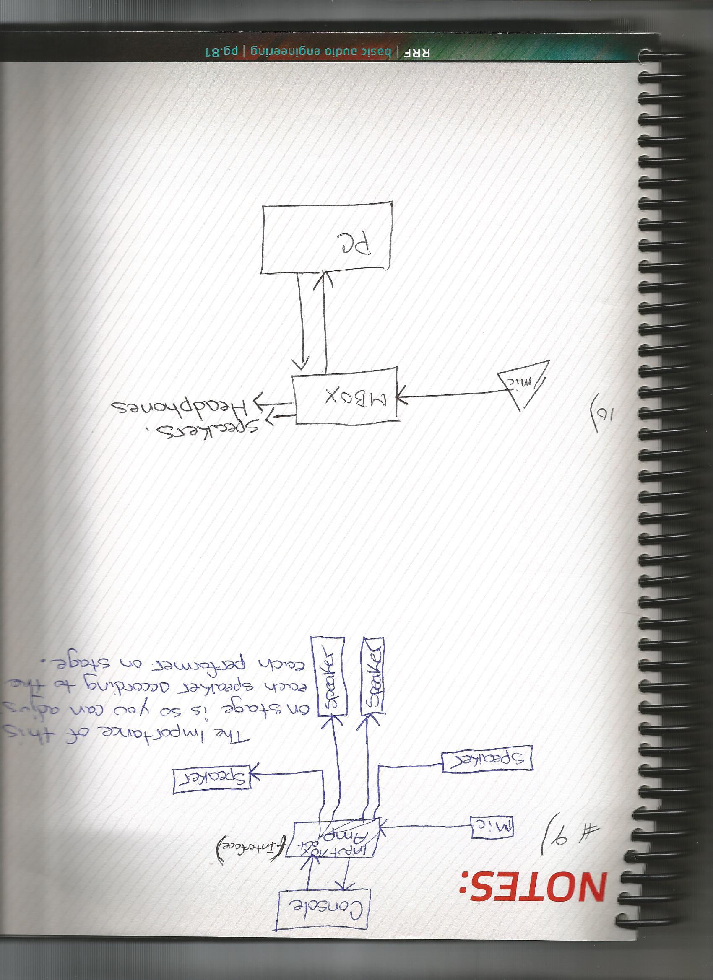

Lesson 7   
Question 9 and 10  
🡨

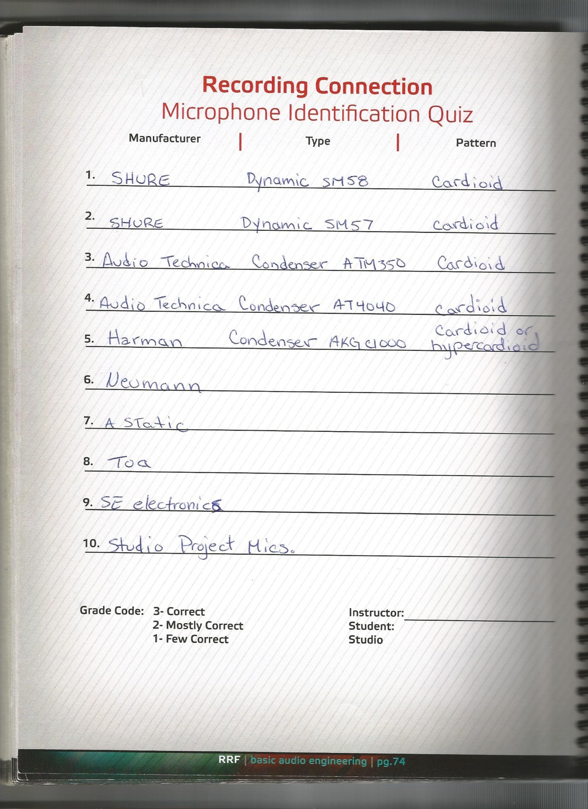

Please Accept This as Lesson 6 Microphone Quiz.