 | Ishika Charles
-
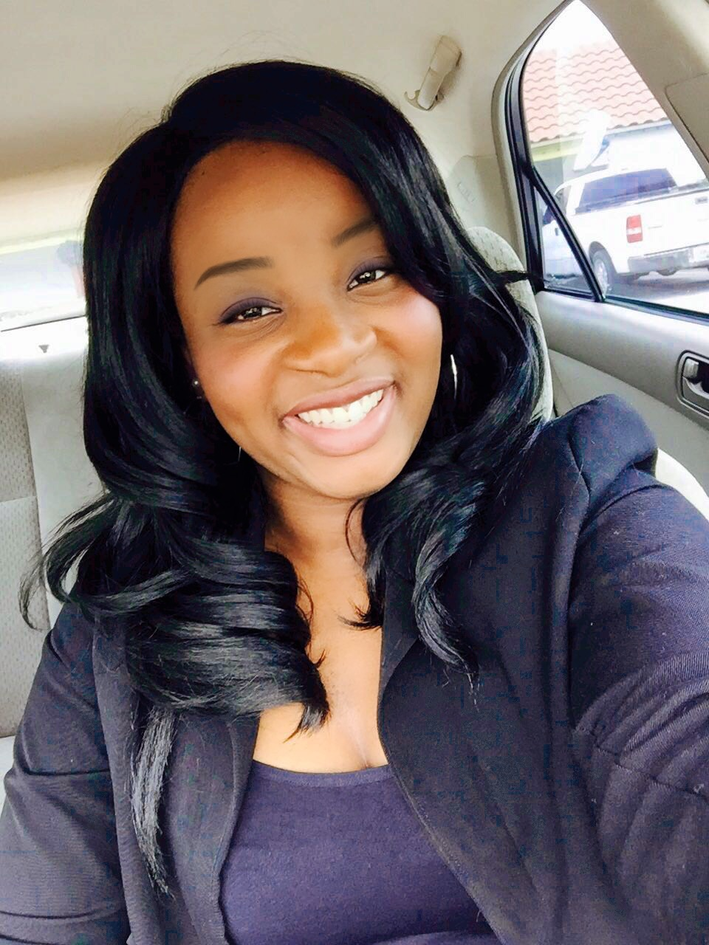 | 2460 East Aragon Blvd Sunrise Florida 33313  1-954-683-7291  ishikacharles@gmail.com/zoe@surfbvi.com  https://www.facebook.com/teampurpose/  https://soundcloud.com/ishika-charles
Biography

Blessed with tremendous talent is Ms. Ishika Charles who started singing from a tender age of two and commenced playing the keyboard and drums at six. She developed an innate passion for music while sharing her talent with the world at large. She embraced every opportunity ministering to people in song even when she travelled around the world with her father. As she grew in the music arena, she learnt the Bass at the age of 12. She founded the band “Ishika and SFC (SoulJahz for Christ).
In 2010, she graduated at the Cedar International School and proceeded to further her education at Lee University from 2010 – 2012, during which period she joined the school’s choir named “Evangelistic Singers”. In 2011, she achieved the position of Music Director. She gained tremendous exposure from travelling to New York, New Jersey, and Boston. In 2013, Ishika launched her first CD titled “I Got a Purpose’’ and released her second CD “Ishika Charles Project” in 2015 both at a live concert held at the New Testament Church of God International Worship Centre in Tortola, British Virgin Islands. In June, 2016 she was placed in the Top Three in a Christian based competition “America’s Got Anointing”.
She currently serves as the Music Director at the New Life Fellowship Centre Church of God in Florida, USA. She is now pursuing her vision to become a “Gospel Music Artiste & Producer”.
PERFORMANCE

- Played Bass for Eddie James - Cleveland - 2012
- Gospel Showcase – British Virgin Islands - June 15, 2013
- Concert - Santo Domingo - July 24, 2013
- Open for J Moss - Hope Fest - British Virgin Islands - July 2013
- Women’s Conference - North Carolina - October 19, 2013
- Church of God Caribbean Assembly- Barbados - November 9, 2013
- Open for Vashawn Mitchell – British Virgin Islands - January 13, 2014
- Back up For Todd Dulaney - Hope Fest - British Virgin Islands - July 6, 2014
- BVI Gospel Fest - British Virgin Islands - July 26, 2015
- Church of God Caribbean Assembly - Santo Domingo - Oct 28-30 2015
- Open for Jonathan Nelson - St.Thomas - August 2015
- Americas GOT Anointing - June 3-4 2016
- Gospel Concert – Tampa - July 24, 2016
- Gospel Concert – Tampa - August 10-12 2016
- Boat Gospel Concert – St. Thomas - September 3, 2016

Skills

