- 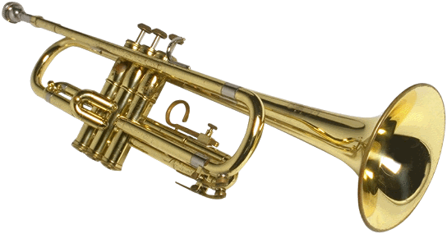
- 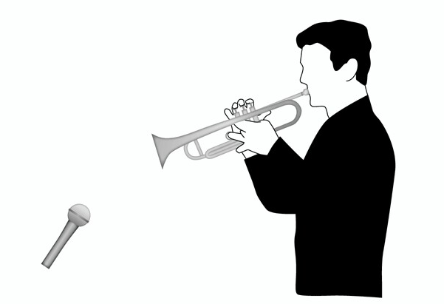

- Because of a trumpet’s frequency, a conical mute can be used to cut back on frequencies below 1.5kHz while encouraging frequencies above 4 kHz. Because of the high sound-pressure levels that can be produced by a trumpet (up to 130 dB SPL) it’s best to place a mic slightly of the bell’s center at a distance of 1 foot or more. When closer placements are needed, a -10 to -20dB pad can help prevent input overload at the mic or console preamp input. Under such close working conditions, a windscreen can help protect the diagram from windblasts.
- Pg. 150

